***Chemistry Laboratory Manual***

***Covenant Christian High School***

***Mr. Joel Minderhoud***

***Revised 2011***

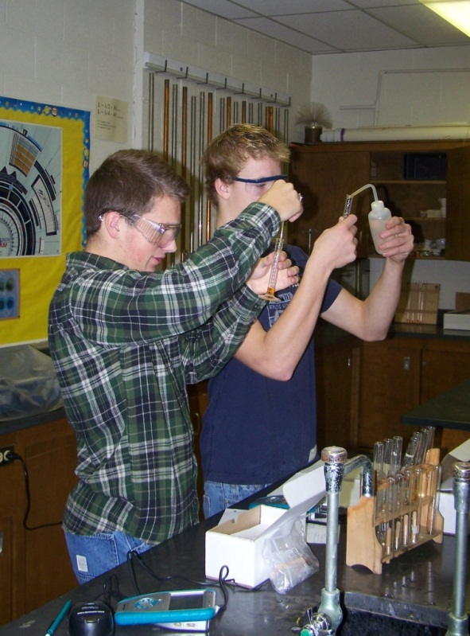 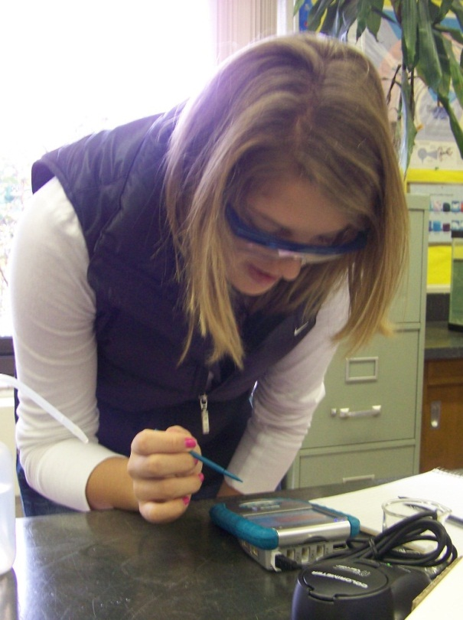

***Introduction***

What follows is an attempt at compiling various experiments designed to introduce the "first-time" Chemistry student to various chemical phenomena. Through various laboratory experiences, whether it be "cook-book" experiments which teach the student the content and skills or whether the experiment is more open-ended and inquiry-based in nature, it is my opinion that the following experiments are representative of the sort of content, skills, and thought processes with which a "first-time" Chemistry student should come in contact. I believe these experiments do an excellent job of giving the student a variety of experiences, developing laboratory skills and methods, introducing the student to various types of technology, and giving the student needed problem solving and calculation-based opportunities and challenges.

Whereas in previous editions I’ve included a lengthy section of information and reading related to the Reformed perspective on Chemistry, in this edition I have separated that out into a second text, entitled ***A Reformed Perspective on the Physical Sciences.*** That section has been made into a separate text, in addition to other practical reasons, because its value and usefulness warranted its own separate binding.

It is my hope that these experiments convey to the students knowledge of God's Creation and His sovereign sustaining powers. May God receive all glory and honor through the use of this book.

**Acknowledgements**

In the few years that I have taught Chemistry I have performed many experiments with my students. I have used for these experiments, those that I remember doing in my own high school education and through out my college years. I have also consulted various textbook companies' laboratory manuals for ideas and complete experiments. Other things that I have done in my classes have been a result of ideas that I have picked up from other teachers at conferences. What I have found, however, is that many procedures in pre-written laboratory materials did not apply well to the circumstances at Covenant Christian High School, or they were too difficult or complicated to follow. What I spent a lot of time doing was explaining and showing the student the proper procedure for each experiment. What I wanted to do was take the main experiments that I do each year with my students and re-write the procedures in a way that I was sure they would understand and in a way which would use the equipment we had available at Covenant Christian High School. The following laboratory manual is a result of a desire to accomplish this.

Obviously, many of these experiments are modifications of experiments performed in other laboratory settings. Special recognition should be given to Pamela Veltkamp for laboratory experiments that have been modified from her Chemistry 103 and 104 Laboratory Manuals from Dordt College and Holt, Rinehart, and Winston's 1999 Modern Chemistry textbook and supplementary materials which have given me ideas which I have used here.

The following labs that are mentioned are modified from the given source. All other labs that are mine, or those I’ve learned in my education but do not know the source, are not listed.

Lab 1 - pictures Addison-Wesley

Lab 3 – modified from Addison-Wesley

Lab 4 - modified from Addison-Wesley with picture from Addison-Wesley

Lab 5 - modified from Modern

Lab 6 – pictures from Addison-Wesley and Modern

Lab 8 – pictures from Addison-Wesley

Lab 9 – modified from Heath with pictures from Addison-Wesley

Lab 10 – modified from Larry Louters, Calvin College, 1989

Lab 11 – modified from Pam Veltkamp

Lab 12 – modified from Flinn Scientific Inc., 1996

Lab 13 - modified from Flinn Scientific Inc., 1996

Lab 14 – modified from Heath

Lab 15 - modified from Flinn Scientific Inc., 1996

Lab 16 - idea from Tim Graham 1997 MSTA conference

Lab 17 - modified from Pamela Veltkamp with picture from Pamela Veltkamp

Lab 18 - picture from Pamela Veltkamp

Lab 19 - modified from Modern with pictures from Modern

Lab 21 – modified from Modern and Pam Veltkamp

Lab 22 – modified from Modern

Lab 26 – modified from Pam Veltkamp

Lab 29 – idea from Tim Graham 1997 MSTA conference

Lab 31 – modified from R. A. Hermann, Chem 13 News, 1984

Lab 32 – modified from Dave Tanis, and Ron Perkins, 1991

Lab 33 – modified from Pam Veltkamp and YSE 1994

Lab 34 – modified from Pam Veltkamp and YSE 1994

Lab 35 – modified from Modern

Lab 36 – modified from Jo A. Beran, 1993

**Bibliography**

Beran, Jo A. Chemistry in the Laboratory. John Wiley and Sons, 1993.

Chemistry. Addison-Wesley Publishing Company, 1997.

Chemistry. D.C. Heath and Company, Lexington, Massachusetts, 1987.

Davis, Raymond et. al. Modern Chemistry. Holt, Rinehart, and Winston, 1999.

Flinn Scientific Inc. Spectrophotometer Laboratory Manual. 1996

Graham, Tim. MSTA Conference. 1997

Hermann, R.A. Chem 13 News, January 1984.

Louters, Larry. Sights and Sounds of Chemistry: Tested Chemical Demonstrations. 1989.

Perkins, Ron. ICE Publication. 1991.

Tanis, Dave. Holland Christian High School. No date.

Veltkamp, Pamela. Laboratory Manual for Chemistry 103 and 104. Dordt College, 1991.

Joel Minderhoud

August 1998

August 2001 – Revised

August 2007 – Second Revision

August 2011 – Third Revision

**Table of Contents**

A. Laboratory Rules, Equipment, Report Write-up Requirements and Directions. 43

B. Experiments:

1. Laboratory Techniques and Observations . . . . . . . . . . . . . . . . . . . . . . . 49

2. Standard Deviation, Uncertainty, and Measurement. . . . . . . . . . . . . . . . . . 53

3. Density . . . . . . . . . . . . . . . . . . . . . . . . . . . . . . . . . . . . . . . . . . . . . . . . . . . 57

4. Introduction to Chromatography . . . . . . . . . . . . . . . . . . . . . . . . . . . . . . . . 59

5. Introduction to Spectrophotometry . . . . . . . . . . . . . . . . . . . . . . . . . . . . . . 61

6. Empirical Formula Determination . . . . . . . . . . . . . . . . . . . . . . . . . . . . . . . 64

7. Types of Reactions . . . . . . . . . . . . . . . . . . . . . . . . . . . . . . . . . . . . . . . . . . 67

8. Qualitative Analysis with Baking Soda and HCl . . . . . . . . . . . . . . . . . . . . . 68

9. Qualitative Analysis with Copper Solution and Iron Nail . . . . . . . . . . . . . . 70

10. Colligative Properties – Boiling Point Elevation . . . . . . . . . . . . . . . . . . . . . 72

11. Qualitative Analysis – What is in my test Tube? . . . . . . . . . . . . . . . . . . . . . 73

12. Spectrophotometry and Copper Ion Identification . . . . . . . . . . . . . . . . . . . 77

13. Spectrophotometry and Water Analysis – Identifying Iron Ions . . . . . . . . . 79

14. Galvanic Corrosion . . . . . . . . . . . . . . . . . . . . . . . . . . . . . . . . . . . . . . . . . . 82

15. Analysis of Chlorophyll Using the Spectrophotometer . . . . . . . . . . . . . . . . 83

16. Boyle's Law . . . . . . . . . . . . . . . . . . . . . . . . . . . . . . . . . . . . . . . . . . . . . . . . 86

17. Percent Aluminum in an Aluminum Can . . . . . . . . . . . . . . . . . . . . . . . . . . . 87

18. Molar Volume of Hydrogen Gas . . . . . . . . . . . . . . . . . . . . . . . . . . . . . . . . 89

19. Specific Heat of a Common Metal . . . . . . . . . . . . . . . . . . . . . . . . . . . . . . . 91

20. Chemical Equilibrium Analysis . . . . . . . . . . . . . . . . . . . . . . . . . . . . . . . . . . 95

21. Spectrophotometry and Equilibrium . . . . . . . . . . . . . . . . . . . . . . . . . . . . . . 98

22. Estimating pH . . . . . . . . . . . . . . . . . . . . . . . . . . . . . . . . . . . . . . . . . . . . . 102

23. Acids/Bases Quantitative Lab – Titration . . . . . . . . . . . . . . . . . . . . . . . . . 104

24. Percent Acetic Acid in Vinegar . . . . . . . . . . . . . . . . . . . . . . . . . . . . . . . . . 105

25. Antacid Analysis . . . . . . . . . . . . . . . . . . . . . . . . . . . . . . . . . . . . . . . . . . . . 107

26. Determination of Molar Mass of an Unknown Solid Acid . . . . . . . . . . . . . 110

27. Melting Point of a Substance . . . . . . . . . . . . . . . . . . . . . . . . . . . . . . . . . . . 111

28. Extraction of Caffeine . . . . . . . . . . . . . . . . . . . . . . . . . . . . . . . . . . . . . . . . 113

29. Percent Sugar in Common Soda Beverages . . . . . . . . . . . . . . . . . . . . . . . . 114

30. Aspirin Synthesis . . . . . . . . . . . . . . . . . . . . . . . . . . . . . . . . . . . . . . . . . . . . 115

31. What Percent of a U.S. Penny is Zinc . . . . . . . . . . . . . . . . . . . . . . . . . . . . 116

32. The Heat Treatment of a Steel Bobby Pin . . . . . . . . . . . . . . . . . . . . . . . . . 117

33. How Hard is My Water? . . . . . . . . . . . . . . . . . . . . . . . . . . . . . . . . . . . . . . 119

34. Water Analysis – How Much Chlorine is in My Water? . . . . . . . . . . . . . . 121

35. How Much Calcium is there in an Eggshell? . . . . . . . . . . . . . . . . . . . . . . . 123

36. Vitamin C Analysis . . . . . . . . . . . . . . . . . . . . . . . . . . . . . . . . . . . . . . . . . . 125

**Safety Rules**

When working in the Chemistry Laboratory room you are to be extremely careful not to injure yourself or others, or to waste or break equipment and supplies. Being created by God and as temples of the Holy Spirit we must be responsible beings in the science laboratory. Our fellow classmates are also temples of the Holy Spirit and we should seek covenant fellowship with them as well. Therefore, we treat them in a respectful manner, esteeming them more than ourselves, and are careful not to injure them. Chemicals and equipment are expensive. Carelessness and horseplay often result in breakage or wasting of the supplies. This is not stewardship. Therefore, we must obey the following science lab rules to ensure everyone's safety and stewardly use of the supplies we have:

* 1. **Do Not Perform Unauthorized Experiments** !!!!!

* 2. **Absolutely No Horseplay Whatsoever** !!!!!

3. Know the location of the fire extinguisher, eye wash, and body shower.

4. Approved safety goggles must be worn at all times. Prescription eye-wear is not sufficient. Contact lenses are discouraged.

5. Always wear shoes and socks in the laboratory - No bare feet or sandals.

6. Tie long hair back and do not wear loose hanging clothes.

7. No eating or drinking in the laboratory.

8. Avoid skin contact with all chemicals. Wash exposed skin immediately with plenty of water.

9. Use the equipment as intended. Return it to its proper place. Clean up.

10. Clean up all spills immediately and appropriately.

11. Report all spillages and injuries to the teacher immediately.

12. Clean up your laboratory area completely before you leave class.

13. Wash your hands thoroughly before leaving lab.

14. Follow instructions carefully !!!!! When in doubt, do not be afraid to ask the teacher for assistance.

* Denotes a rule, that, when broken, results in immediate expulsion from lab and a zero on that activity.

**Commonly Used Laboratory Equipment**

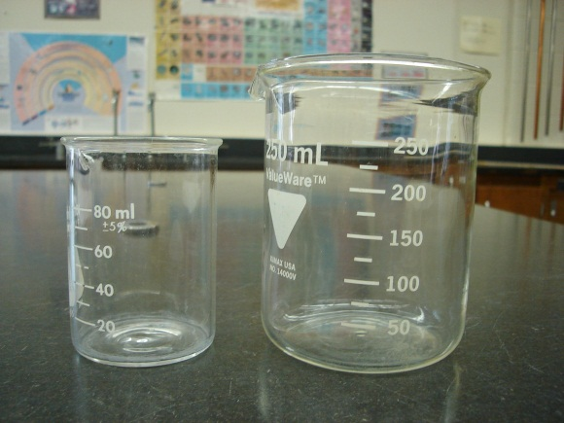 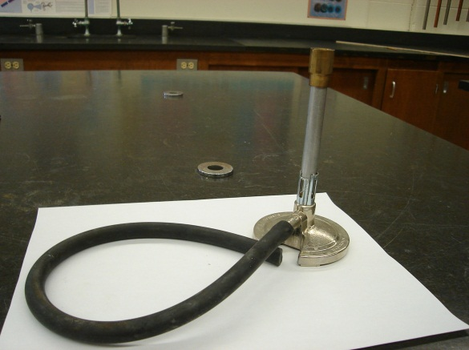

Beakers Bunsen Burner

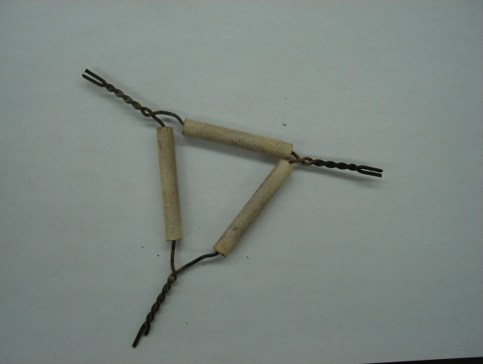 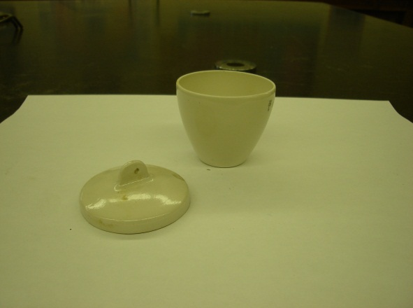

Clay Triangle Crucible and Cover

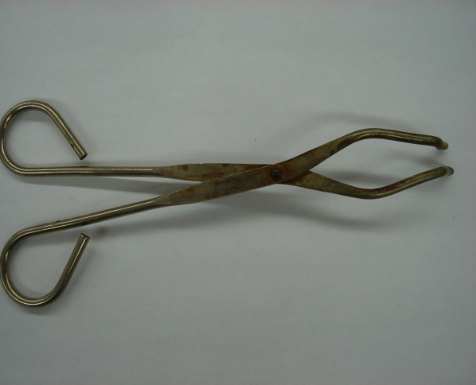 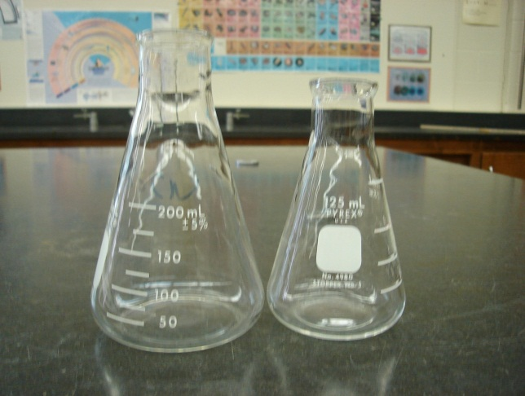

Crucible Tongs Erlenmeyer Flasks

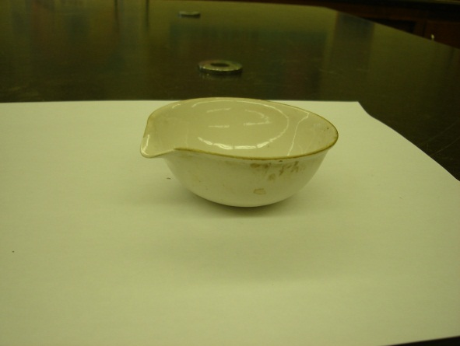 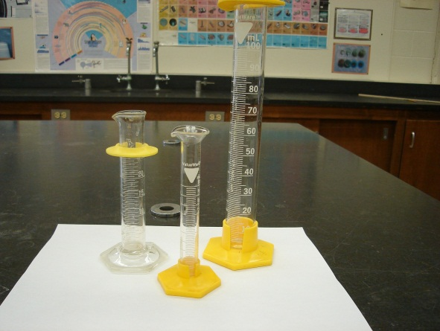

Evaporating Dish Graduated Cylinders

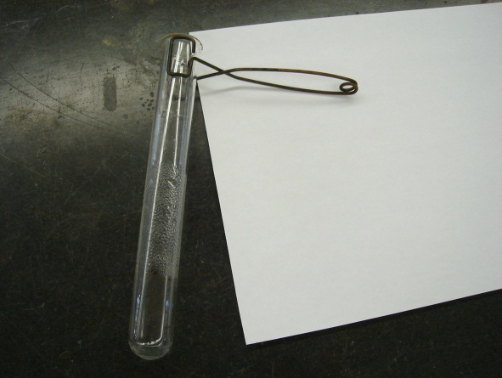 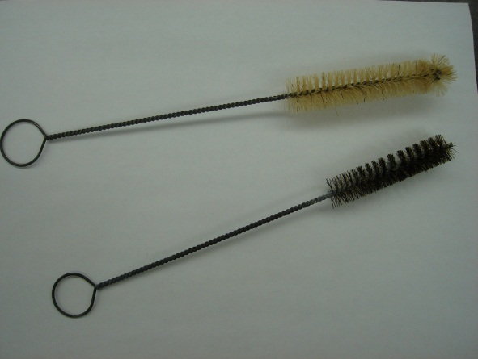

Test tube and test tube holder Test tube cleaner brushes

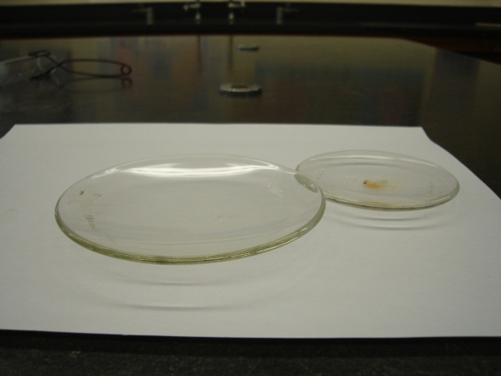 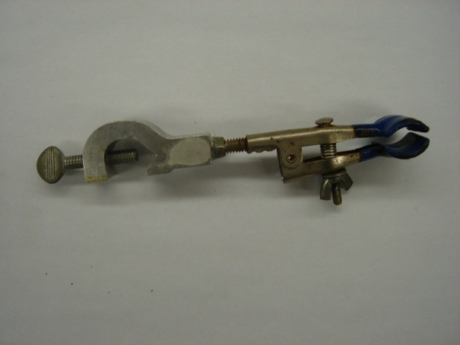

Watch Glasses Test tube or Buret clamp

**Laboratory Grading Sheet**

Name: Date:

Lab:

**Lab Techniques:**

1. Listens to Directions: 0 1 2 3

2. Shows Initiative 0 1 2 3

3. Adapts and is a Problem Solver 0 1 2 3

4. Masters Techniques 0 1 2 3

**Lab Etiquette:**

5. Stays at Proper Lab Station 0 1 2 3

6. Works Without Excessive Noise -2 -1 0 1 2 3

7. Uses Available Time Wisely 0 2 4 6

8. Observes Safety Practices -2 -1 0 1 2 3

9. Cleans Up Lab Station 0 1 2 3

**Comments:**

Key: -2 to 0 = Poor

1 = Fair

2 = Good

3 = Excellent and a Bonus

Your Score:

Total Points: 20

**Laboratory Notebook Requirements**

A lab notebook is an official record of your work. In the work-place, your lab notebook could be used in a court proceeding to establish patent rights. More likely, your lab notebook is an important record that you can return to months, and sometimes, years later to remember what you did and what your results were. Therefore, quality record keeping is critical.

**Collecting the Data:**

I recommend the following:

a.) Leave the first two pages empty for a table of contents.

b.) During a lab, take down the necessary data as neatly as possible on the “graph” side of the paper.

c.) Write down all the measurements, observations, etc that happen in lab.

d.) Write down unique procedures, in detail, in the order you did them (sometimes we can come back to your procedure and find where something went wrong).

**Writing the Informal Lab Report:**

I recommend the following:

a.) Use the “lined” side of the paper to write the lab report

b.) It is called “informal” because we do not include all the sections of a lab report

c.) Required sections are:

* Purpose/Rationale:
* Data/Results: include all calculations and graphs
* Discussion: What does all the data mean? What did you learn about science?

d.) The informal lab report is to be done neatly. The original data on the “graph” side may be more messy because it was collected in a more hurried environment, but the lab report should not have scribbles etc.

e.) Failure to have all sections completed will result in an Incomplete Grade or an E.

**NB:**

* All sections are vital
  + Can’t make conclusions or discussion without clear data, calculations, and graphs
  + Data, graphs, and calculations are meaningless without commentary and explanation in the Discussion section

**Lab Work**

* Is generally done as a group because of lack of resources or equipment.
* Performed as a group in order to learn how to work together as a group.
* Lab reports (notebook or formal reports) are to be done **individually**, unless otherwise directed.

**Formal Lab Report Write-up**

Some experiments may require a formal typed lab-report. Some of these may be done individually and others as a group. A formal lab report should look as follows:

---------------------------------------------------------------------------------------------------------

Student Name

Subject

Teacher's Name

Date

**Title**

**Purpose**: The purpose(s) of the lab is given here. "To find the percent acetic acid in vinegar."

**Apparatus**: You should list the items used in the experiment:

* + - Beaker
    - Thermometer

**Procedure**: In your own words, briefly describe what you did in the lab. It should be detailed enough so that someone who has not done the lab could pick up your lab-report and accomplish the experiment. Do not use personal pronouns. "I put five ml of hexane . . . " is unacceptable. You should rather write "5 ml of hexane were placed in the beaker".

**Data/Results**: Here you place all pertinent graphs, data tables, calculations, observations, percent error calculations etc.

**Discussion**: Discuss the meaning of the results. Do they obey the laws? What is expected? Why? Do they fit with what is expected? What do the results

or data tell us about the system being studied? What are the causes of error? What spiritual truths are evident in this lab?

This section will vary in length over the year. The goal of the section is to see if the experiment fulfilled the stated objectives. This section also gives the student an opportunity to articulate what (s)he understands about the scientific concepts involved in the experiment. What did this lab teach you about science?

**Questions:** In this section the student should answer any questions that are found at the end of the lab. It goes without saying that the “question is found in the answer” and that the answers are in complete sentences.

***Formal Lab Reports should always be typed in their entirety and double-spaced.***